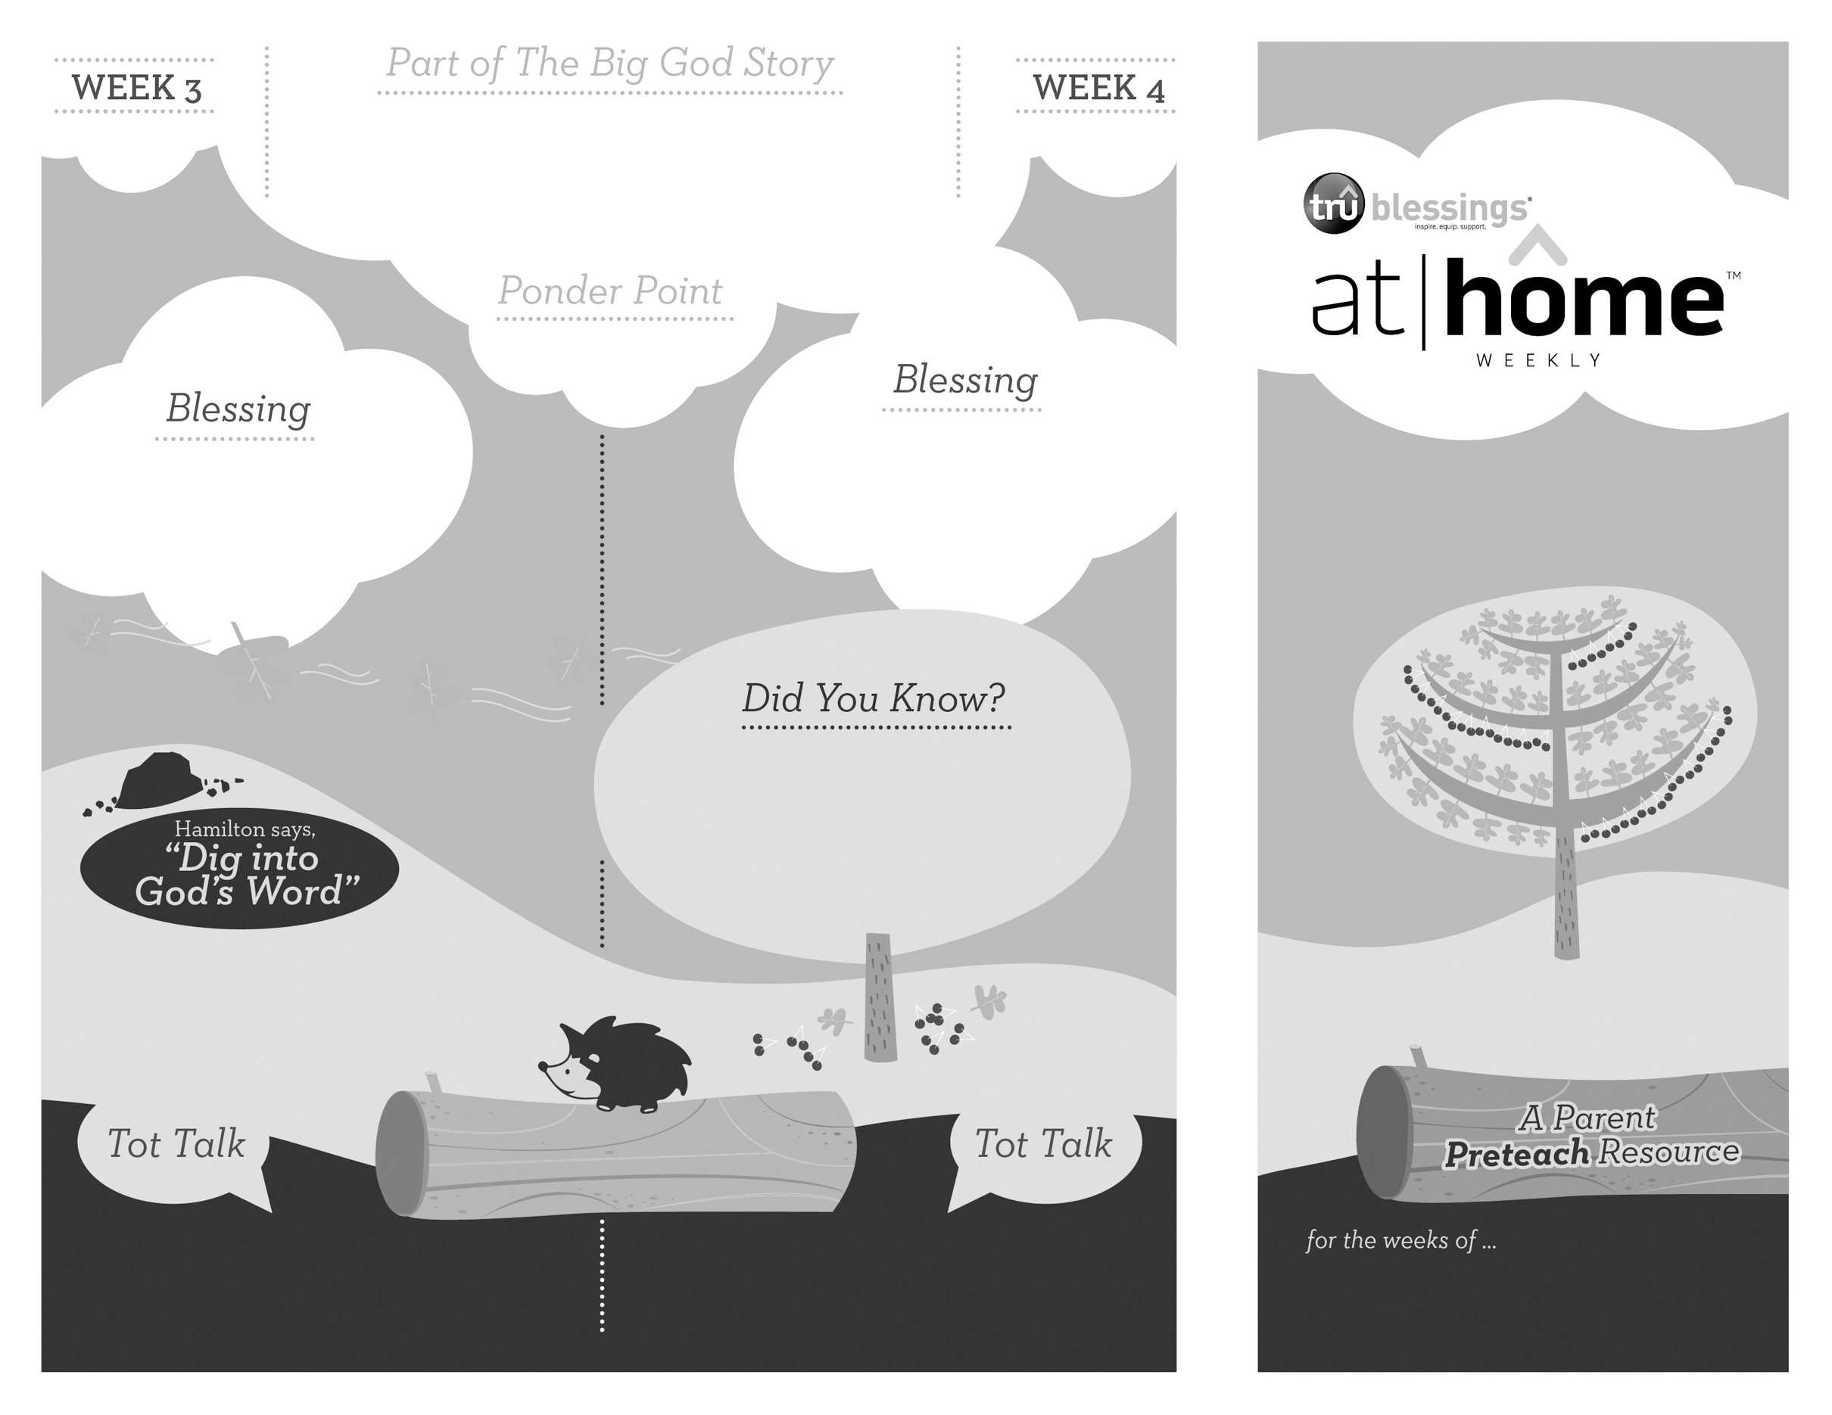

***GOD IS WORSHIPPED***

• All of creation was made to worship God.

• Worship is not just singing songs to God—it is an attitude of awe, thankfulness, service, and praise that can be part of our lives every day   
(Luke 19:37–40).

.

**Worshipping through Psalms**

**Psalm 27:6; 30:11; 95:2; 98:4; 108:1; 149:3**

The God of all creation is holy and worthy of all worship. We were created to worship Him. Scripture tells us that if God’s people do not praise Him for who He is, the rocks will cry out in praise of Him.

1.12

1.11

Open a Bible and read Psalm 95:6:

***“Come, let us bow down in worship, let us kneel before the Lord our Maker.”***

(Insert your child’s name)**,** ***may you always remember that you were made to worship God.***

***Read Psalm 95:1–6.*** Remind your child that God is worthy of our worship because He is above all.

Explain to your children that you can worship God in everything you do. Dancing, giving, art, singing, silence, sharing, and thanksgiving are just some of the ways we can worship Him.

Share with your child the ways in which you worship God. Talk together about why we worship Him.

***Your child learns by mimicking your actions. Allow her to imitate your posture as she watches you praise God for who He is in the everyday rhythm of your life.***

Type to enter text

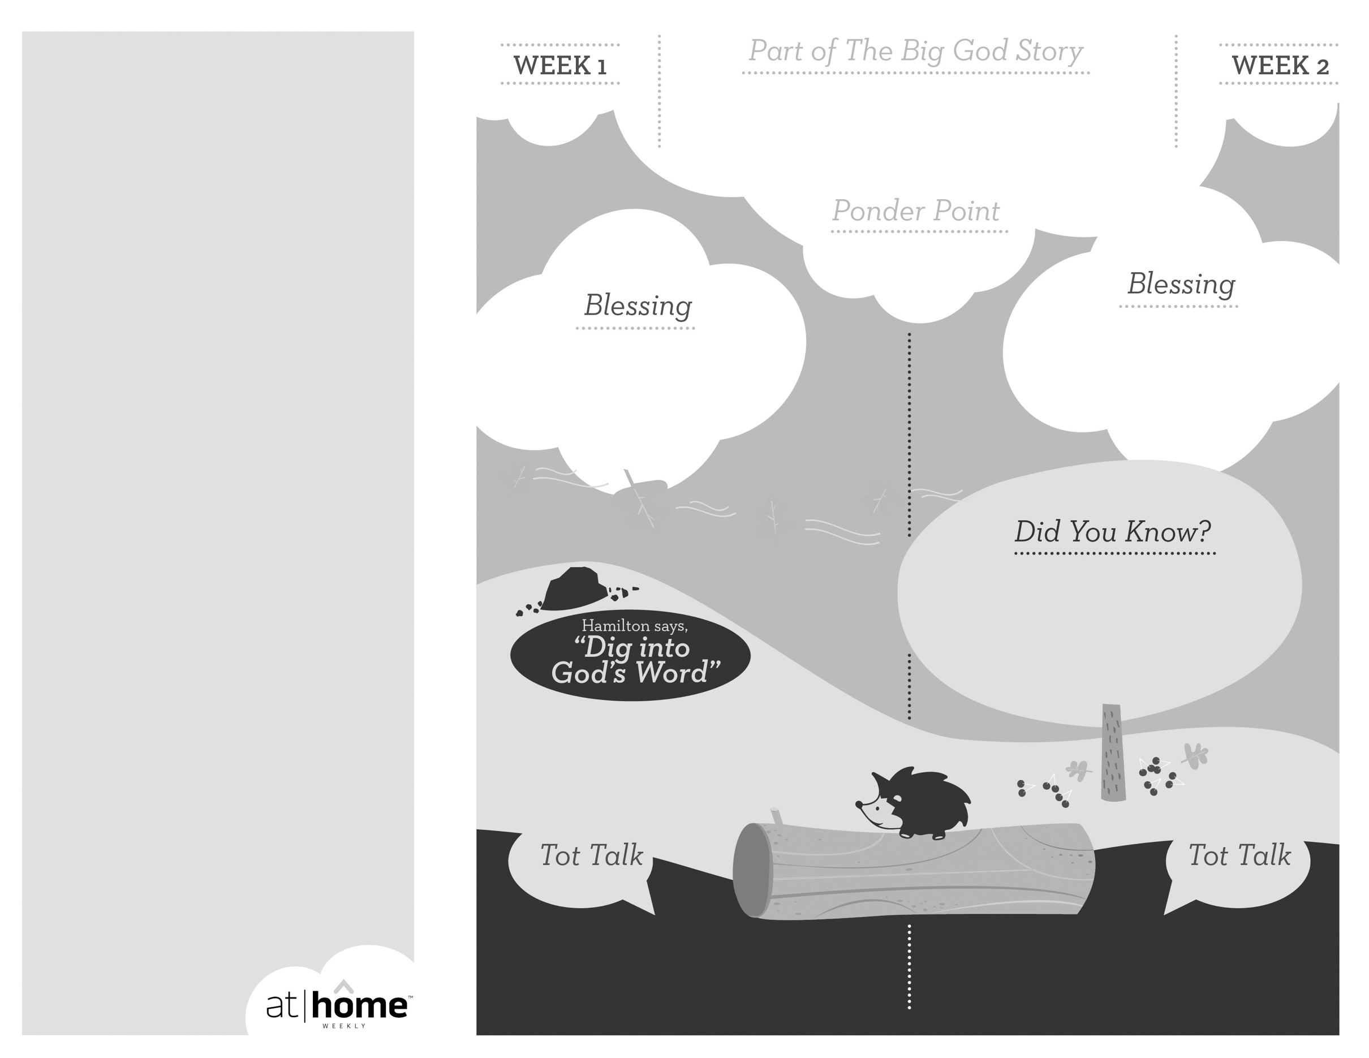

***Young children are rarely still for extended periods of time. Encourage your child to play fun, simple games with you that allow him to practice being quiet in small time increments. This will help your child as he grows and learns to listen for God’s voice.***

***Read 1 Samuel 3:1–9.*** Remind your child that God spoke to Samuel and He can speak to us too!

(Insert your child’s name)**,** ***may you hear God’s voice and follow Him every day.***

**1 Samuel 3**

As a young man, the prophet Samuel lived in the temple studying under Eli the priest. One night, as Samuel was sleeping, he heard someone call his name. Eli realized it was God’s voice Samuel was hearing. He told Samuel to tell God that he was  
 present and listening.

***God has given parents the privilege of being the primary spiritual nurturers of their children’s faith.***

The At Home Weekly is designed to reinforce that truth by allowing your family to have time in God’s Word**before your child attends church each week.** It will provide you with ways to introduce The Big God Story and have age-appropriate conversations with your little one as you prepare her for what she will be experiencing in church for the next four weeks.

Research has shown that children between the ages of two and four learn best through repetition. Because of this, TruBlessings will spend two weeks on the same part of **The Big God Story** and the **Ponder Point.**

Each week you will receive a new **Blessing.** A blessing is a prayer of commission, a portion of Scripture, or words of encouragement and guidance. While giving the blessing, you may desire to lay hands on your child as you speak the Scripture or pray a prayer over him.

**Hamilton the Hedgehog** will play a role in your child’s experience in church each week—be sure to ask about him. He loves to **Dig into God’s Word.** The passage of Scripture provided will assist you as you reinforce the Ponder Point. **Did You Know?** has fun facts about this part of The Big God Story for you to share with your child. And **Tot Talk** is simply a conversation starter to assist you as you spiritually parent.

***GOD SPEAKS***

1.10

1.9

© 2017 David C Cook. TruResources are developed in   
partnership with **ROCK**HARBOR Church and a   
national network of family and children’s ministry   
leaders. All rights reserved. Reproducible for  
church use only.

Open a Bible and read Psalm 40:8:

***“I desire to do your will, my God;  
your law is within my heart.”***

• Samuel lived in the temple of the  
Lord while he learned how to serve  
God from Eli the priest.

• Samuel grew up hearing God’s  
voice and later served the Lord as a  
priest, prophet, and judge.

Spend a short period of time in silence with your child. See what sounds your child can identify that he may not have heard otherwise (a bird chirping, the wind blowing through the trees, etc.) Ask: ***“How does God speak?”***

Share a story with your child of a time when you heard God speak to you or direct you.